Lab Objective

Learn how to create and configure Connection Request Policies

**Lab Procedures**

**1.** Log in to RWDC01 as **Contoso\administrator** using the password **Password01**. The Server Manager console opens.

**2.** On Server Manager, click Tools > Network Policy Server. The Network Policy Server console opens.

**3.** Double-click Policies in the NPS tree.

**4.** Right-click Connection Request Policies, and then click New. The New Connection Request Policy Wizard starts.

**5.** In the Policy name text box, type **Connection Request Policy 1** in the Policy name text box.

**6.** Under Type of network access server, select *Remote Access Server (VPN-Dial up)*. Click Next.

**7.** Take a screen shot of the New Connection Request Policy window by pressing Alt+Prt Scr and then paste it into your Lab13_worksheet file in the page provided by pressing Ctrl+V.

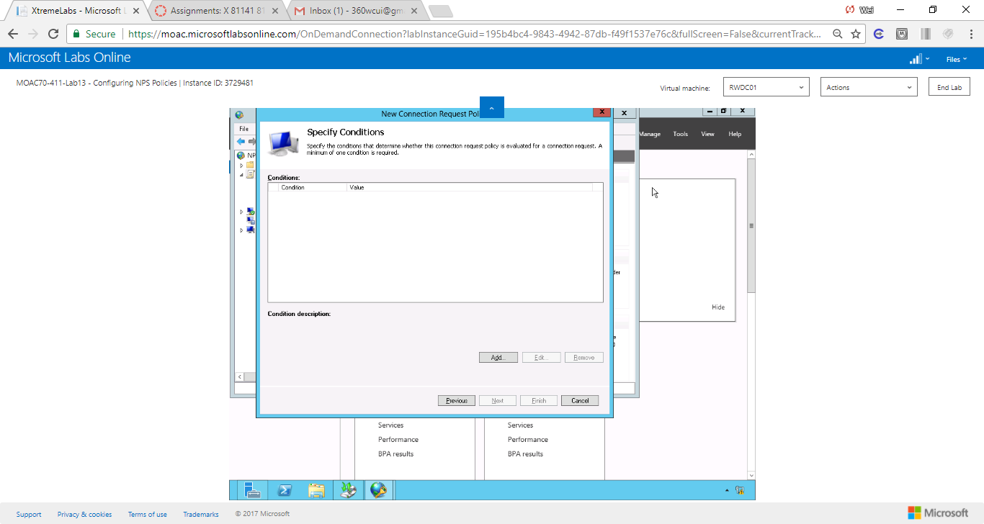

Figure Screen shot shows the Specify Conditions for new Connection Request Policy

**8.** On the Specify Conditions page, click Add.

**9.** When the Select condition dialog box opens, click Tunnel Type and click Add.

**10.** When the Tunnel Type dialog box opens, click *IP Encapsulating Security Payload in the Tunnel-mode (ESP)*, *Layer Two Tunneling Protocol (L2TP)*, and *Secure Socket Tunneling Protocol (SSTP)*. Click OK.

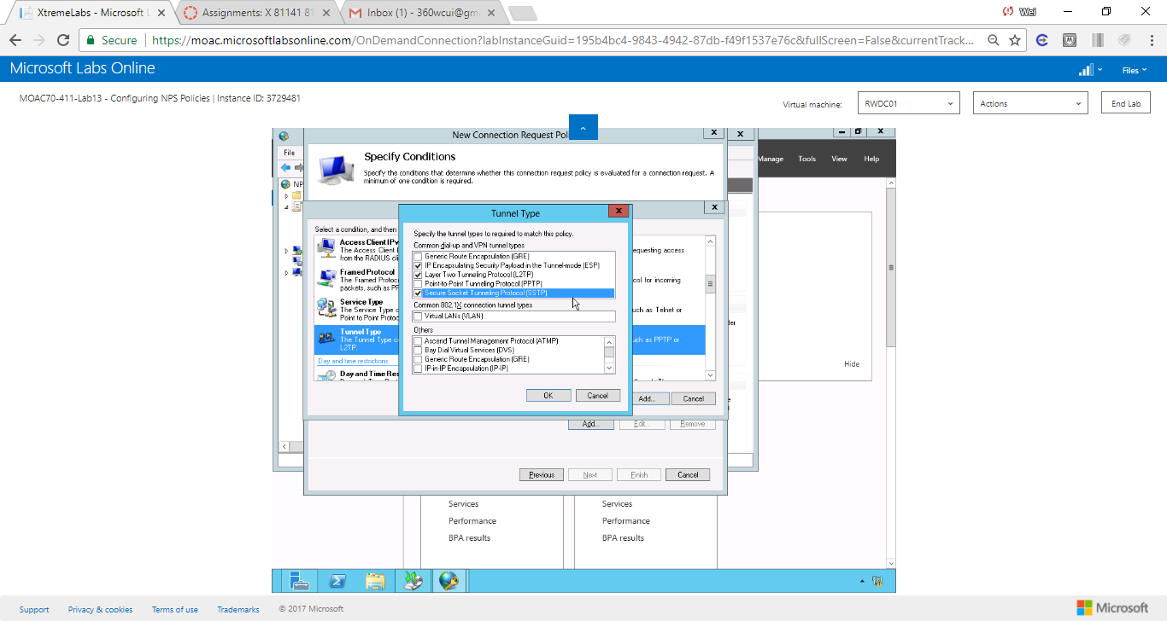

Figure 2 Screen shot shows IP Encapsulating Security Payload in the Tunnel-mode (ESP), Layer Two Tunneling Protocol (L2TP), and Secure Socket Tunneling Protocol (SSTP) are selected.

**11.** Click Add again, click Day and Time Restrictions, and click Add.

**12.** When the Day and time restrictions dialog box opens click Monday through Friday, 8 AM to 5 PM, and click Permitted. A blue box should appear as shown in Figure 13-1. Click OK.

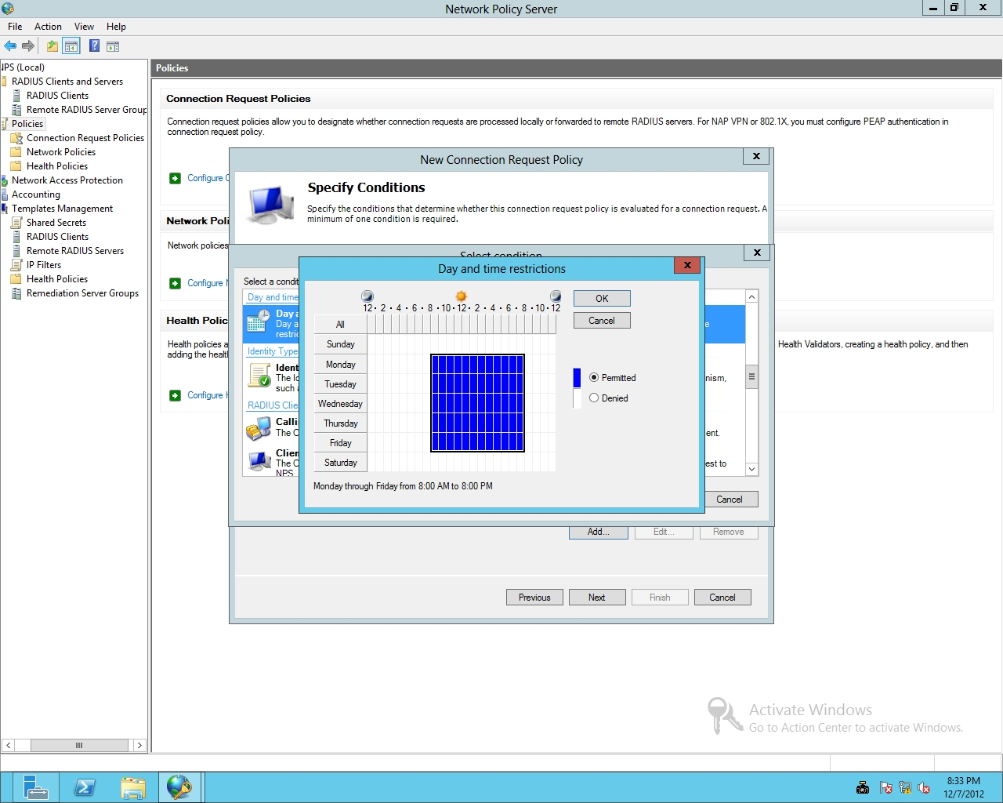

Figure 13-1

Restricting access by day and time

**13.** Back on the Specify Conditions page, click Next.

**14.** On the Specify Connection Request Forwarding page, click Next.

**15.** On the Specify Authentication Methods page, click Next.

**16.** On the Configure Settings page, click Next.

**17.** On the Completing Connection Request Policy Wizard page, click Finish. When created, the Connection Policy is listed in the Connection Request Policies pane.

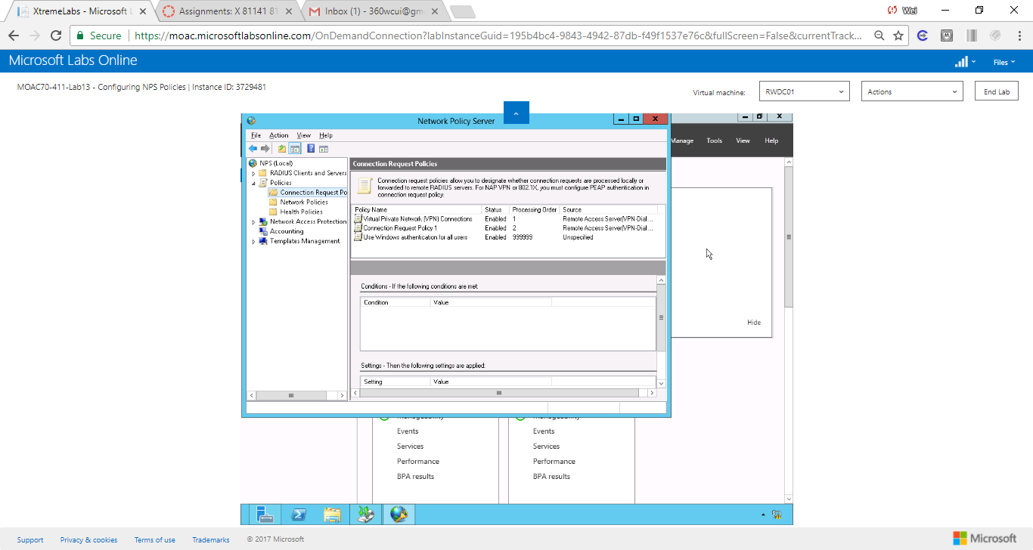

Figure Screenshot shows Connection Request Policy 1 listed in the pane.

**18.** Leave the Network Policy Server console open for the next exercise.

End of exercise.

**Lab Summary**

In this exercise, I learned how to create and configure Connection Request Policies. Connection request policies are sets of conditions and settings that allow network admins to designate which Remote Authentication Dial-In User Service (RADIUS) servers perform the authentication and authorization of connection requests that the server running Network Policy Server (NPS) receives from RADIUS clients. Connection request policies can be configured to designate which RADIUS servers are used for RADIUS accounting. By default, the request policy processes all requests locally.